**Activity 3**

* Create an ec2 instance with
  + ubuntu 20.04 AMI
  + imported key pair
  + 22 and 80 port open to all
  + instance type: t2.micro
* Install webserver => Apache with php

sudo apt update

sudo apt install apache2 stress -y

sudo apt install php libapache2-mod-php php-mysql -y

echo '<?php phpinfo(); ?>' > info.php

sudo cp info.php /var/www/html/info.php

Solution 1: Create ec2 instance with above options. SSH into EC2 and execute the commands

SSH and execute the following commands  
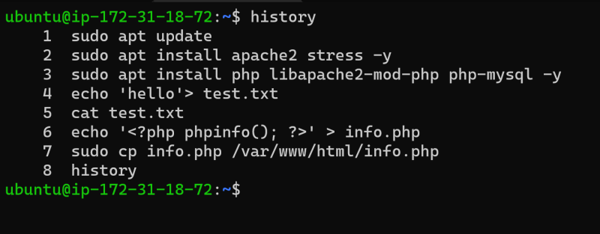

Now navigate to http://<publicip>/info.php  
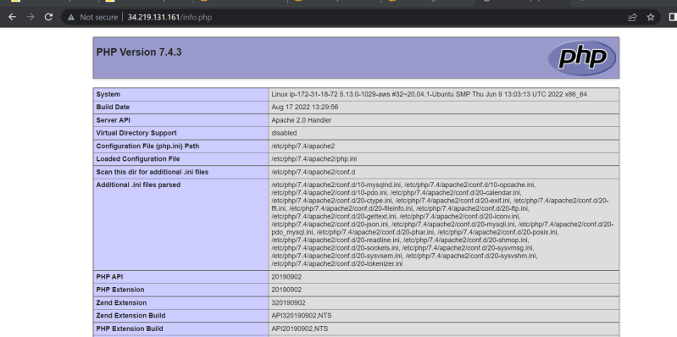

Solution 2: User Data

Open Advanced details while creating ec2 instance and navigate to the user data section  
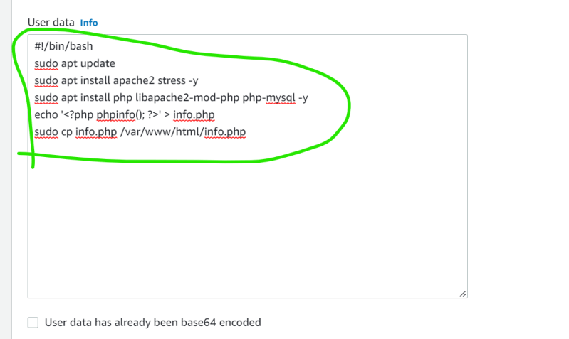

Now launch ec2 instance

Now navigate to http://<publicip>/info.php  
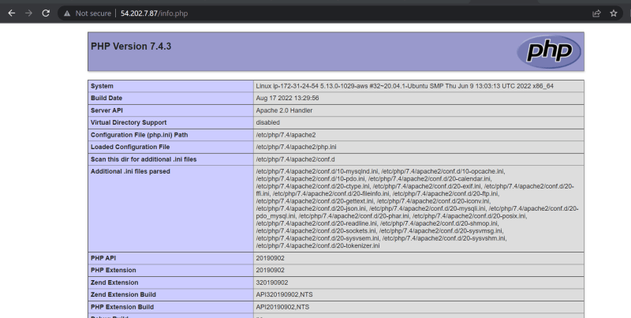

Userdata is the script that will be executed as a root user by your aws instance.

This script gets execute only while creating the ec2 instance.

Lets verify the logs  
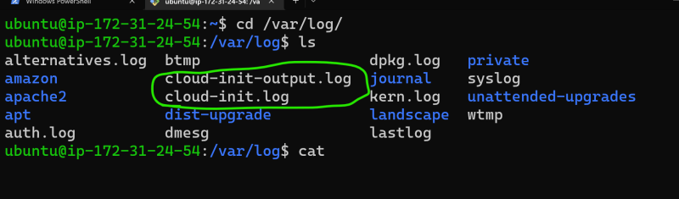

* Cloud init [ <https://cloudinit.readthedocs.io/en/latest/>

**AWS EC2 instance Lifecycle**

* The billing part of the ec2 instance will be applicable only for on-demand instances.
* Refer the below image for instance states  
  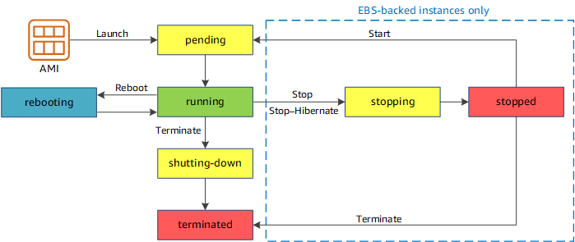
* Actions that can be performed on ec2
  + launch => Create an ec2 instance
  + stop => stop the ec2 instance which is running
  + start => start the ec2 instance which is stopped
  + terminate => terminate the running or stopped ec2 instance
  + stop-hibernate => hibernate the ec2 instance which is running